Used Model – Segformer-b4 licensed by MIT
Val IOU - 0.92

Test IOU - 0.9990

EPOCH’S :-

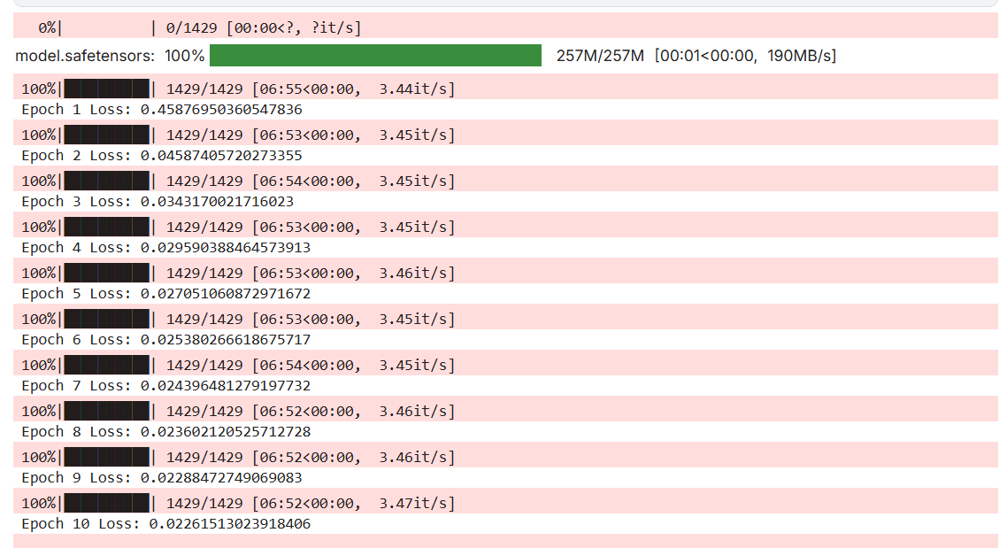

OUTPUT :-

